Query 1

LIST THE ENTIRE PARTICIPATED RELATION IN THE

DESCENDING ORDER OF DAMAGE AMOUNT.

# Query 2

FIND THE AVERAGE DAMAGE AMOUNT

# Query 3

DELETE THE TUPLE WHOSE DAMAGE AMOUNT IS BELOW

THE AVERAGE DAMAGE AMOUNT

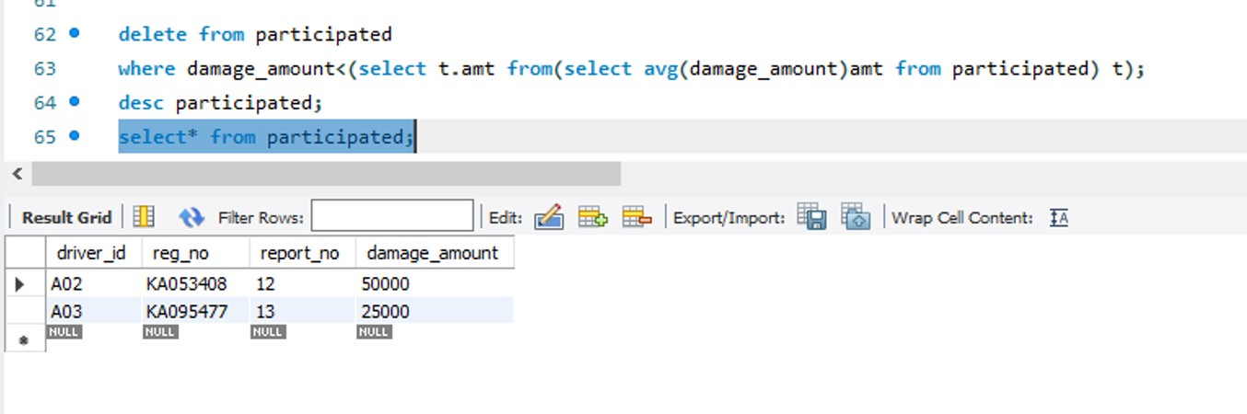

Query 4

LIST THE NAME OF DRIVERS WHOSE DAMAGE IS GREATER

THAN THE AVERAGE DAMAGE AMOUNT.

# Query 5

FIND MAXIMUM DAMAGE AMOUNT.

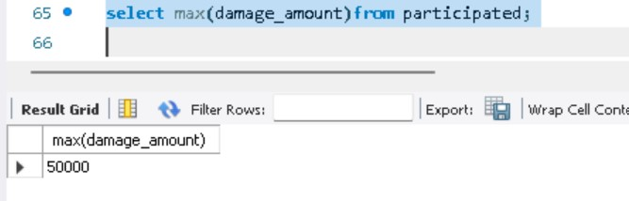

Spot query

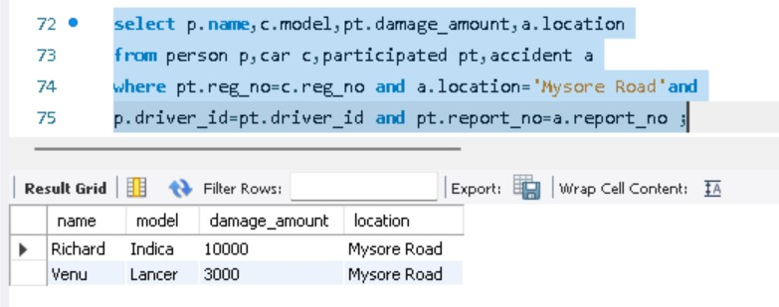Find driver_id, model and damage_amount who participated in accident at location Mysore Road